WWW.CCTVDMS.COM
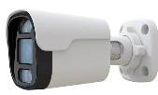  B9510WI | 5MP IP FULL-COLOR BULLET CAMERA  30m illumination  Smart H264+/H265+  WDR.3D DNR.HLC.BLC  IP67 .12V DC | 2.389.000
B9510WI A | 5MP IP FULL-COLOR BULLET CAMERA  30m illumination  Smart H264+/H265+  WDR.3D DNR.HLC.BLC AUDIO  IP67 .12V DC | 2.490.000
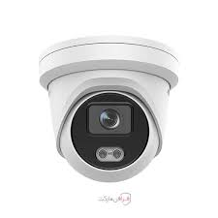  D9510WI | 5MP IP FULL-COLOR CAMERA  30m illumination  Smart H264+/H265+  WDR.3D DNR.HLC.BLC  IP67 .12V DC | 2.389.000
D9510WI A | 5MP IP FULL-COLOR CAMERA  30m illumination  Smart H264+/H265+  WDR.3D DNR.HLC.BLC AUDIO  IP67 .12V DC | 2.490.000
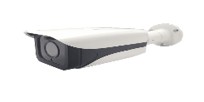  B9520WIB | 5MP IP FULL-COLOR BULLET CAMERA PLUS  80m illumination  Smart H264+/H265+  WDR.3D DNR.HLC.BLC  IP67 .12V DC | 2.890.000
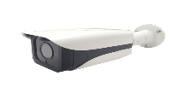  B9520WIBA | 5MP IP FULL-COLOR BULLET CAMERA PIUS  80m illumination  Smart H264+/H265+  WDR.3D DNR.HLC.BLC AUDIO  IP67 .12V DC | 2.990.000
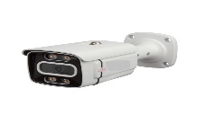  B9820WIB | 8MP IP FULL-COLOR BULLET CAMERA PLUS  80m illumination  Smart H264+/H265+  WDR.3D DNR.HLC.BLC  IP67 .12V DC | 3.890.000
B9820WIBA | 8MP IP FULL-COLOR BULLET CAMERA PIUS  80m illumination  Smart H264+/H265+  WDR.3D DNR.HLC.BLC AUDIO  IP67 .12V DC | 3.990.000
B9820WIBM | 8MP IP FULL-COLOR BULLET CAMERA PLUS  80m illumination  Smart H264+/H265+  LNS, motorized  WDR.3D DNR.HLC.BLC  IP67 .12V DC | 4.600.000
B9820WIBMA | 8MP IP FULL-COLOR BULLET CAMERA PIUS  80m illumination  Smart H264+/H265+  LNZ, motorized  WDR.3D DNR.HLC.BLC AUDIO  IP67 .12V DC | 4.700.000

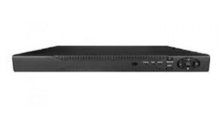 | NVR 10CH HI  4K 8MG  XMEYE | 3.100.000
 | .  NVR 16CH HI  4K 8MG  XMEYE | 4.290.000
 | NVR 32CH HI  4K 8MG  XMEYE | 8.890.000
 | NVR 64CH HI  4K 8MG  XMEYE | 19.860.000
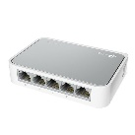 | S 10/100  5 PORT | 850.000
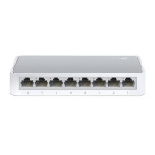 | S 10/100  8 PORT | 1.150.000
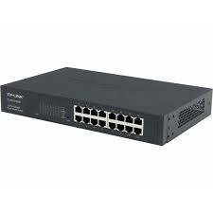 | S 10/1000  16 PORT POE | 2.900.000
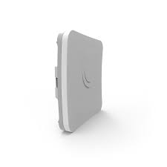 | Mikrotik wireless ROUTER  SXT SQ | 2.900.000
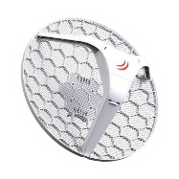 | Mikrotik wireless ROUTER  LHG 5 | 6.800.000
 | DMS

