WWW.CCTVDMS.COM
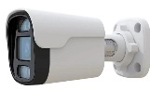  B262W | B262W DMS BULLET CAMERA  LNZ.3.6 1080P  IR.30M FULL COLER  12V DC | 1.190.000
B272WB | B262WB DMS BULLET CAMERA  LNZ.3.6 1080P  IR.30M FULL COLER  12V DC | 1.380.000
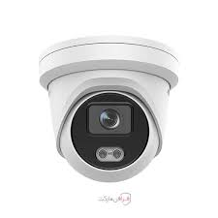  D262W | D262W DMS  LNZ.3.6 1080P  IR.30M FULL COLER  12V DC | 1.190.000
D562W | D562W DMS  LNZ.3.6 5MG  IR.30M FULL COLER  12V DC | 1.380.000
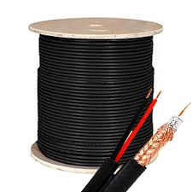 | RG59/96/23/0.7 | 15.000
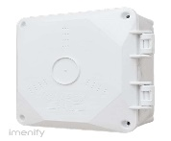 | RAINBOX | 50.000
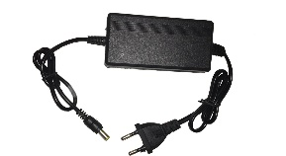 | 12V DC 2 A | 120.000
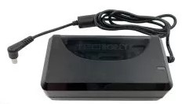 | 12V/DC/3A | 250.000

